**Hibernate Annotation-**

We can create hibernate application with annotation. There are many annotation that can be used to create the hibernate application such as @Entity, @Id, @Table, etc.

Package for annotation is javax.persistence.*;

**Why?**

You don’t need to create mapping (hbm) file.

CRUD operation in hibernate

**Hibernate- Insert operation**

Maven project

File->New->Maven Project->

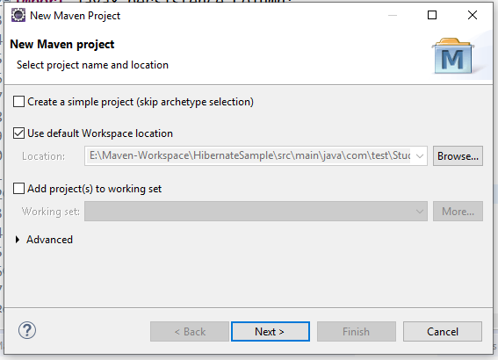

Click on create simple project

Click on Next button

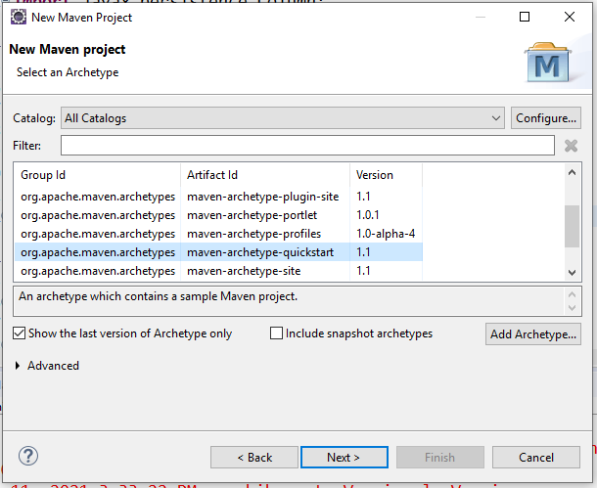

Click on Next button

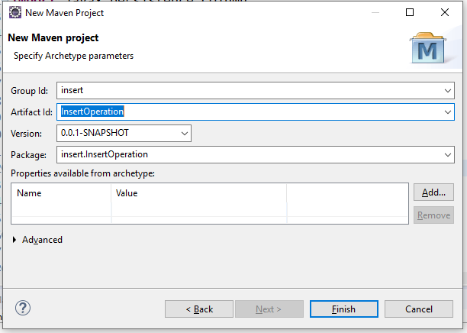

Mention the group id as any name, artifact id as any name.

Where group id is the project id and artifact id is project name.

Click on finish button.

Maven project structure looks like as

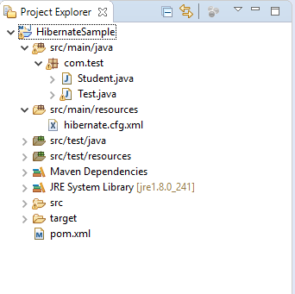

Go to pom.xml add hibernate and MySQL jar dependencies in that file

**Pom.xml**

<dependencies>

<dependency>

<groupId>org.hibernate</groupId>

<artifactId>hibernate-core</artifactId>

<version>4.1.4.Final</version>

</dependency>

<dependency>

<groupId>mysql</groupId>

<artifactId>mysql-connector-java</artifactId>

<version>8.0.21</version>

</dependency>

</dependencies>

**Student.java- POJO class**

**package** com.test;

**import** javax.persistence.Column;

**import** javax.persistence.Entity;

**import** javax.persistence.GeneratedValue;

**import** javax.persistence.GenerationType;

**import** javax.persistence.Id;

**import** javax.persistence.Table;

@Entity

@Table(name="student")

**public** **class** Student {

@Id

@Column(name = "id")

@GeneratedValue(strategy = GenerationType.***AUTO***)

**private** **int** id;

@Column(name = "name")

**private** String name;

@Column(name = "city")

**private** String city;

@Column(name = "mobile")

**private** String mobile;

**public** **int** getId() {

**return** id;

}

**public** **void** setId(**int** id) {

**this**.id = id;

}

**public** String getName() {

**return** name;

}

**public** **void** setName(String name) {

**this**.name = name;

}

**public** String getCity() {

**return** city;

}

**public** **void** setCity(String city) {

**this**.city = city;

}

**public** String getMobile() {

**return** mobile;

}

**public** **void** setMobile(String mobile) {

**this**.mobile = mobile;

}

}

**hibernate.cfg.xml**

<?xml version=*"1.0"* encoding=*"UTF-8"*?>

<!DOCTYPE hibernate-configuration SYSTEM

"classpath://org/hibernate/hibernate-configuration-3.0.dtd">

<hibernate-configuration>

<session-factory>

<property name=*"hibernate.connection.driver_class"*>com.mysql.jdbc.Driver</property>

<property name=*"hibernate.connection.url"*>jdbc:mysql://localhost:3306/test</property>

<property name=*"hibernate.connection.username"*>root</property>

<property name=*"hibernate.connection.password"*>root</property>

<property name=*"hibernate.dialect"*>org.hibernate.dialect.MySQLDialect</property>

<property name=*"hbm2ddl.auto"*>create</property>

<property name=*"show_sql"*>true</property>

<mapping class=*"com.test.Student"*></mapping>

</session-factory>

</hibernate-configuration>

**Test.java**

**package** com.test;

**import** org.hibernate.Session;

**import** org.hibernate.SessionFactory;

**import** org.hibernate.Transaction;

**import** org.hibernate.cfg.Configuration;

**public** **class** Test {

**public** **static** **void** main(String[] args) {

Configuration configuration = **new** Configuration();

configuration.configure("hibernate.cfg.xml");

SessionFactory sessionFactory = configuration.~~buildSessionFactory~~();

Session session = sessionFactory.openSession();

Transaction transaction = session.beginTransaction();

// insert data into database

Student student = **new** Student();

student.setName("ram");

student.setCity("pune");

student.setMobile("9595972678");

session.save(student);

transaction.commit();

session.close();

System.***out***.println("Record saved successfully.");

}

}

Output-



Go to database and check the results whether record is inserted or not.

**Hibernate- Update operation**

**Student.Java**

**package** com.demo;

**import** javax.persistence.Column;

**import** javax.persistence.Entity;

**import** javax.persistence.GeneratedValue;

**import** javax.persistence.GenerationType;

**import** javax.persistence.Id;

**import** javax.persistence.Table;

@Entity

@Table(name="student")

**public** **class** Student {

@Id

@Column(name = "id")

@GeneratedValue(strategy = GenerationType.***AUTO***)

**private** **int** id;

@Column(name = "name")

**private** String name;

@Column(name = "city")

**private** String city;

@Column(name = "mobile")

**private** String mobile;

**public** **int** getId() {

**return** id;

}

**public** **void** setId(**int** id) {

**this**.id = id;

}

**public** String getName() {

**return** name;

}

**public** **void** setName(String name) {

**this**.name = name;

}

**public** String getCity() {

**return** city;

}

**public** **void** setCity(String city) {

**this**.city = city;

}

**public** String getMobile() {

**return** mobile;

}

**public** **void** setMobile(String mobile) {

**this**.mobile = mobile;

}

}

**hibernate.cfg.xml**

<?xml version=*"1.0"* encoding=*"UTF-8"*?>

<!DOCTYPE hibernate-configuration SYSTEM

"classpath://org/hibernate/hibernate-configuration-3.0.dtd">

<hibernate-configuration>

<session-factory>

<property name=*"hibernate.connection.driver_class"*>com.mysql.jdbc.Driver</property>

<property name=*"hibernate.connection.url"*>jdbc:mysql://localhost:3306/test</property>

<property name=*"hibernate.connection.username"*>root</property>

<property name=*"hibernate.connection.password"*>root</property>

<property name=*"hibernate.dialect"*>org.hibernate.dialect.MySQLDialect</property>

<property name=*"hbm2ddl.auto"*>update</property>

<property name=*"show_sql"*>true</property>

<mapping class=*"com.test.Student"*></mapping>

</session-factory>

</hibernate-configuration>

**Test.java**

**package** com.demo;

**import** org.hibernate.Session;

**import** org.hibernate.SessionFactory;

**import** org.hibernate.Transaction;

**import** org.hibernate.cfg.Configuration;

**public** **class** Test {

**public** **static** **void** main(String[] args) {

Configuration configuration = **new** Configuration();

configuration.configure("hibernate.cfg.xml");

SessionFactory sessionFactory = configuration.~~buildSessionFactory~~();

Session session = sessionFactory.openSession();

Transaction transaction = session.beginTransaction();

Student student = (Student) session.get(Student.**class**, 1);

student.setName("rohit");

session.update(student);

transaction.commit();

session.close();

sessionFactory.close();

System.***out***.println("Record updated successfully.");

}

}

Run the application

Go to database and check the results.



**Hibernate- Delete operation**

**Student class**

**package** com.demo;

**import** javax.persistence.Column;

**import** javax.persistence.Entity;

**import** javax.persistence.GeneratedValue;

**import** javax.persistence.GenerationType;

**import** javax.persistence.Id;

**import** javax.persistence.Table;

@Entity

@Table(name="student")

**public** **class** Student {

@Id

@Column(name = "id")

@GeneratedValue(strategy = GenerationType.***AUTO***)

**private** **int** id;

@Column(name = "name")

**private** String name;

@Column(name = "city")

**private** String city;

@Column(name = "mobile")

**private** String mobile;

**public** **int** getId() {

**return** id;

}

**public** **void** setId(**int** id) {

**this**.id = id;

}

**public** String getName() {

**return** name;

}

**public** **void** setName(String name) {

**this**.name = name;

}

**public** String getCity() {

**return** city;

}

**public** **void** setCity(String city) {

**this**.city = city;

}

**public** String getMobile() {

**return** mobile;

}

**public** **void** setMobile(String mobile) {

**this**.mobile = mobile;

}

}

**hibernate.cfg.xml**

<?xml version=*"1.0"* encoding=*"UTF-8"*?>

<!DOCTYPE hibernate-configuration SYSTEM

"classpath://org/hibernate/hibernate-configuration-3.0.dtd">

<hibernate-configuration>

<session-factory>

<property name=*"hibernate.connection.driver_class"*>com.mysql.jdbc.Driver</property>

<property name=*"hibernate.connection.url"*>jdbc:mysql://localhost:3306/test</property>

<property name=*"hibernate.connection.username"*>root</property>

<property name=*"hibernate.connection.password"*>root</property>

<property name=*"hibernate.dialect"*>org.hibernate.dialect.MySQLDialect</property>

<property name=*"hbm2ddl.auto"*>update</property>

<property name=*"show_sql"*>true</property>

<mapping class=*"com.test.Student"*></mapping>

</session-factory>

</hibernate-configuration>

**Test.Java**

**package** com.demo;

**import** org.hibernate.Session;

**import** org.hibernate.SessionFactory;

**import** org.hibernate.Transaction;

**import** org.hibernate.cfg.Configuration;

**public** **class** Test {

**public** **static** **void** main(String[] args) {

Configuration configuration = **new** Configuration();

configuration.configure("hibernate.cfg.xml");

SessionFactory sessionFactory = configuration.~~buildSessionFactory~~();

Session session = sessionFactory.openSession();

Transaction transaction = session.beginTransaction();

Student student = (Student) session.get(Student.**class**, 1);

session.delete(student);

transaction.commit();

session.close();

sessionFactory.close();

System.***out***.println("Record deleted successfully.");

}

}

Run the application

Hibernate: delete from student where id=? Record deleted successfully.

**Hibernate- Select operation**

**Student.java**

**package** com.demo;

**import** javax.persistence.Column;

**import** javax.persistence.Entity;

**import** javax.persistence.GeneratedValue;

**import** javax.persistence.GenerationType;

**import** javax.persistence.Id;

**import** javax.persistence.Table;

@Entity

@Table(name="student")

**public** **class** Student {

@Id

@Column(name = "id")

@GeneratedValue(strategy = GenerationType.***AUTO***)

**private** **int** id;

@Column(name = "name")

**private** String name;

@Column(name = "city")

**private** String city;

@Column(name = "mobile")

**private** String mobile;

**public** **int** getId() {

**return** id;

}

**public** **void** setId(**int** id) {

**this**.id = id;

}

**public** String getName() {

**return** name;

}

**public** **void** setName(String name) {

**this**.name = name;

}

**public** String getCity() {

**return** city;

}

**public** **void** setCity(String city) {

**this**.city = city;

}

**public** String getMobile() {

**return** mobile;

}

**public** **void** setMobile(String mobile) {

**this**.mobile = mobile;

}

}

**hibernate.cfg.xml**

<?xml version=*"1.0"* encoding=*"UTF-8"*?>

<!DOCTYPE hibernate-configuration SYSTEM

"classpath://org/hibernate/hibernate-configuration-3.0.dtd">

<hibernate-configuration>

<session-factory>

<property name=*"hibernate.connection.driver_class"*>com.mysql.jdbc.Driver</property>

<property name=*"hibernate.connection.url"*>jdbc:mysql://localhost:3306/test</property>

<property name=*"hibernate.connection.username"*>root</property>

<property name=*"hibernate.connection.password"*>root</property>

<property name=*"hibernate.dialect"*>org.hibernate.dialect.MySQLDialect</property>

<property name=*"hbm2ddl.auto"*>update</property>

<property name=*"show_sql"*>true</property>

<mapping class=*"com.test.Student"*></mapping>

</session-factory>

</hibernate-configuration>

**Test.Java**

**package** com.demo;

**import** java.util.*;

**import** org.hibernate.Query;

**import** org.hibernate.Session;

**import** org.hibernate.SessionFactory;

**import** org.hibernate.cfg.Configuration;

**public** **class** Test {

**public** **static** **void** main(String[] args) {

Configuration cfg = **new** Configuration();

cfg.configure("hibernate.cfg.xml");

SessionFactory sessionFactory = cfg.~~buildSessionFactory~~();

Session session = sessionFactory.openSession();

// pass the class name

Query query = session.createQuery("from Student");

List<Student>students = query.list();

**for** (Student student : students) {

System.***out***.println("ID="+student.getId());

System.***out***.println("City="+student.getCity());

System.***out***.println("Mobile="+student.getMobile());

System.***out***.println("Name="+student.getMobile());

}

session.close();

sessionFactory.close();

System.***out***.println("Record retrieved successfully.");

}

}

Run the application

Output

Hibernate: select student0_.id as id1_0_, student0_.city as city2_0_, student0_.mobile as mobile3_0_, student0_.name as name4_0_ from student student0_

ID=1

City=pune

Mobile=7575858595

Name=7575858595

ID=2

City=mumbai

Mobile=8585959575

Name=8585959575

Record retrieved successfully.

**Primary key auto generator-**

Hibernate will generate primary key auto generated internally we don’t need to pass id manually.

**Why?**

Suppose in booking movie ticket, there are some field such as id, name, time, etc. if first user pass the id as 1, name as ram, time as 2 pm and second user pass the id as 1, name as shyam, time as 2 pm, second user get the exception as primary key must be unique, He could not book the ticket. To overcome this problem, we should go for primary key auto generator.

**Generator classes-**

There are total 8 types of id generator as

1. Assigned
2. Increment
3. Sequence
4. Identity
5. Native
6. Hilo
7. Foreign
8. Custom generators

**Assigned-**

This is the default generator class used by the hibernate, if we do not specify <generator> element under id element then hibernate by default it will select as “assigned”

If generator class is assigned, then user is responsible for assigning the primary key value.

Example-

<id name="id">

<generator/>

</id>

**Increment**

Application will responsible to generate the id.

if first time storing the records into database, it will get the max value from database , so here max value is 0 then it will calculate the formula max value +1 then answer is 1 so, it will store the records at first position.

Example-

<id name="id">

<generator class="increment"/>

</id>

**Identity**

Database will responsible to generate the id, application will not responsible to generate the id.

Suppose application will read 3 inputs which is passed by user then it will pass that input directly to database except id.so the database will responsible to increment the id.

Note- MYSQL and DB2 database only supports only identity generator class.

Example-

<id name="id">

<generator class="identity"/>

</id>

**Sequence**-

Whenever you get the next value from sequence. It will automatically increment into hibernate sequence table. Application will get next hibernate sequence value, it will read 3 input from view layer and id so total is 4. Then these values updated into table(student is table name).

Example-

<id name="id">

<generator class="sequence"/>

</id>

**Hilo-**

Application will responsible to generate the id.

for the first record, the id value will be inserted as 1

for the second record the id value will be inserted as 32768

for the next records the id value will be incremented by 32768 and will stores into the database (i mean adds to the previous)

Example-

<id name="id">

<generator class="hilo"/>

</id>

**Native-**

It the combination of identity, sequence and hilo.

Example-

<id name="id">

<generator class="native"/>

</id>

**Foreign**-

It uses the id of another associated object, mostly used with <one-to-one> association.